screenshot

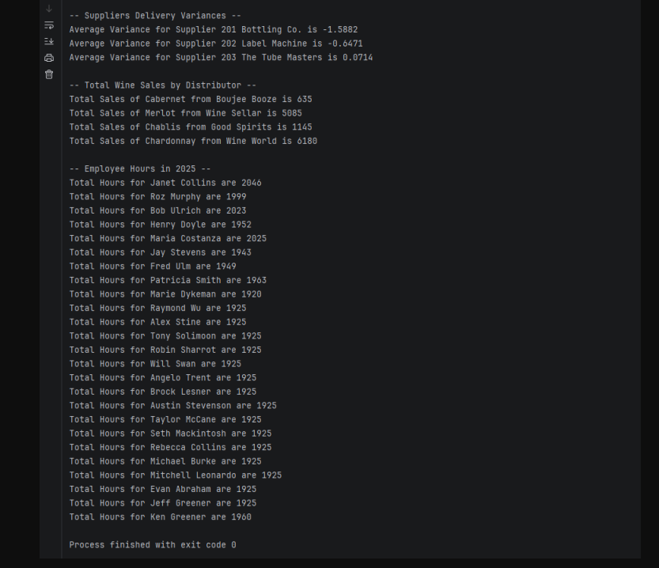

Reports:

Report 1: Supplier delivery variance
With the 3 suppliers, it was found that:
- Tube Masters was consistent throughout the majority of the year, with one minor incident in June
- Label Machine was consistent in the mid-year but tends to lose traction at the end of the year, carrying that trend into the next, until tapering off to that mid-year flow
- Bottling Co. is consistently erratic with deliveries, a problem that needs to be addressed either through a price adjustment or a supplier pivot.
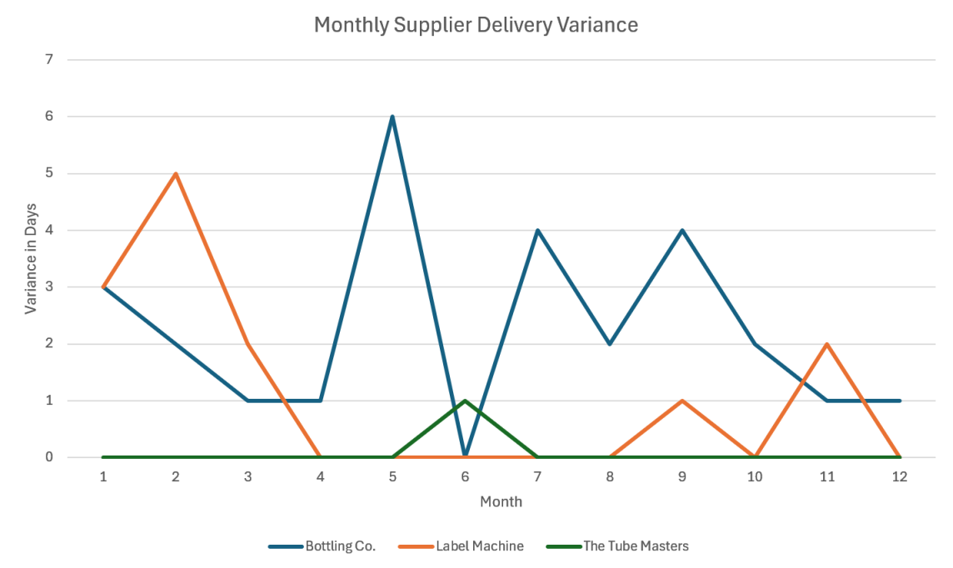

Report 2:
With the 4 Wine Types, it was found that:
- Wine World(Chardonnay) and Wine Sellar(Merlot) were best sellers, selling a combined 11265 cases
- With Boujee Booze and good spirits only selling a combined 1780
- 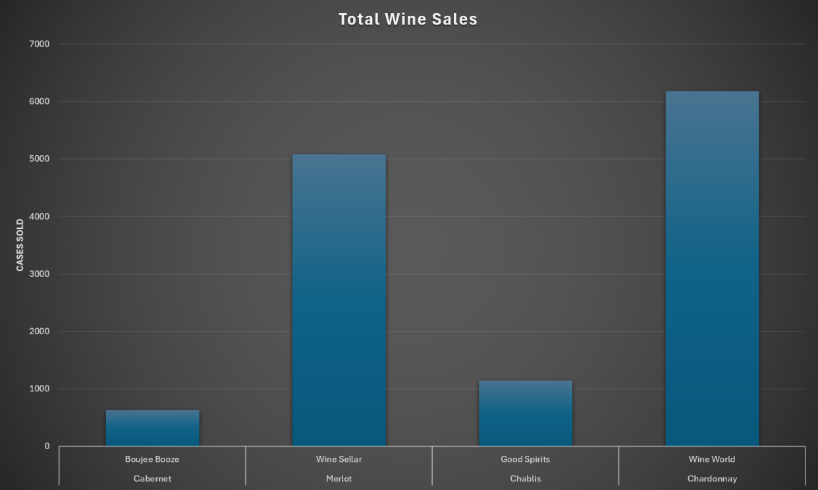kkhggg

Report 3:
Based on the average 40 hr work week, it can be said that:
- Management has been working longer hours than production employees
- The production manager has been taking time off, allowing Ken Greener to fill in as leadership
- All hourly employees are clocking the standard amount, barring several outliers

